**Problem Statement**

**Product Dissection for top leading Platforms**

Welcome to this case study on dissecting and designing products for top leading platforms. In this case study, you will delve into the intriguing world of schema design for a prominent platform of your choice. Your task is to choose a top leading platform, research its features, and meticulously craft a schema design that encapsulates the essence of its functionality. By focusing on key entities, attributes, and relationships, you will gain invaluable insights into how data architecture drives the platform's effectiveness.

**Step 1: Choose a Leading Platform**

Select a leading platform of your choice, which could span various domains such as social media, e-commerce, finance, or any other industry. This choice will form the foundation of your exploration into its schema design.

**Step 2: Research:**

Thoroughly research the platform you have selected. Investigate its core features, functionalities, and user interactions. Identify the top features that define its user experience and contribute significantly to its popularity.

**Step 3: Product Dissection and Real World Problems solved by the platform**

In this step, you will meticulously analyze the platform's standout features and how they provide innovative solutions to real-world challenges. By identifying key functionalities that resonate with users, you'll unravel how the platform effectively addresses problems and enhances user experiences. This dissection will serve as the foundation for understanding how the schema design aligns with the platform's core objectives.

**Step 4: Case Study on the real world problems and approach to solving them**

In this pivotal step, you will expand on the real-world challenges uncovered in Step 3 through a comprehensive case study. Delve into specific instances where users encountered difficulties and showcase how the platform's unique features provided effective solutions. By dissecting the approach taken by the platform to overcome these challenges, you'll gain a deeper appreciation for the platform's user-centric design philosophy and how it shapes the schema design.

**Step 5: Schema Design Based on Top Features**

Based on the features you have identified, craft a schema design that reflects the platform's data structure. Focus on the key entities, attributes, and relationships that underpin the chosen features. Your schema should capture the essence of how the platform organises and utilises its data.

**Step 6: Rationale Behind the Design**

While creating the schema design, consider the rationale behind the platform's choices. Reflect on why certain entities and relationships were chosen and how they align with the platform's goals. This will help you understand the strategic decisions driving the schema's architecture.

**Step 7: Create an ER Diagram**

Utilize tools like the Miro platform or similar applications to create an illustrative Entity-Relationship (ER) diagram. This diagram should vividly depict the entities, attributes, and relationships present within your schema design. The ER diagram will serve as a visual representation of your insights.

**Step 8: Presentation of Findings**

Present your findings in a clear and concise manner. Showcase your understanding of how the schema design impacts the platform's functionality and user experience. Explain how your chosen features are integrated into the schema and how the schema's structure supports the platform's objectives.

**Task Details:**

1. **Answer Submission:** Your submission should include well-structured solutions for all provided questions related to product schema designs.
2. **Video Creation:** Create an informative and engaging video where you thoroughly explain the Case Study.
3. **Depth and Clarity:** Ensure your solutions are detailed and showcase your understanding of product schema design principles. Similarly, in the video, provide clear explanations that are easy to understand for a wide audience.
4. **Creativity Encouraged:** You are welcome to utilise visuals, diagrams, or creative elements to enhance the clarity and impact of your explanations.

**Note:**

1. Duplicate this document and proceed to write your solutions and prepare your video.
2. Include the video link in this document before final submission.

Best of luck in completing this project and showcasing your prowess in dissecting and designing product schema for leading platforms! **For reference, we have also conducted a case study on Instagram, which you can find below. This case study will provide you with valuable insights into how schema design plays a pivotal role in shaping the functionality and success of a prominent platform.**



**Product Dissection for Snapchat**

### **Company Overview:**

Snapchat is a multimedia messaging app developed by Snap Inc. Founded in 2011 by Evan Spiegel, Bobby Murphy, and Reggie Brown, Snapchat has grown into a prominent social media platform known for its unique features and focus on ephemeral content sharing. The company is headquartered in Santa Monica, California, and it went public in 2017 under the parent company Snap Inc. Snapchat has become especially popular among younger users, making it a key player in the social media landscape.

### **Product Dissection and Real-World Problems Solved by Snapchat:**

Snapchat, a popular multimedia messaging app, has effectively tackled real-world challenges through its unique product offerings. With a primary focus on ephemeral content and real-time communication, Snapchat has revolutionized how users connect and share moments. By allowing users to send self-destructing photos and videos, Snapchat provides a solution to the need for privacy and authenticity in a digital age.

One of Snapchat's key features is the disappearing nature of its content. This addresses the challenge of privacy and self-expression, as users can share moments without the fear of long-term consequences. This feature is especially appealing to a younger audience who values their privacy and seeks more genuine interactions. It also encourages spontaneous and unfiltered sharing, fostering a sense of authenticity.

In conclusion, Snapchat's product design has successfully addressed real-world challenges by providing a platform that values privacy, authenticity, real-time sharing, and creative self-expression. It caters to a specific audience seeking more immediate and ephemeral interactions in an ever-evolving digital landscape.

**Case Study: Real-World Problems and Snapchat's Innovative Solutions**

Snapchat, a prominent multimedia messaging app, has introduced innovative solutions to address real-world challenges in the realm of digital communication. In an era where privacy concerns were mounting, Snapchat identified the need for more private and ephemeral content sharing. To tackle this, Snapchat pioneered the concept of self-destructing photos and videos, effectively addressing concerns about the permanence of digital footprints. Users could share moments with confidence that their content would disappear after viewing.

#### **Problem 1: Balancing Privacy and Self-Expression**

**Real-World Challenge:** In an era of digital oversharing, individuals often face a dilemma between self-expression and privacy. Many people hesitate to share personal moments and experiences on traditional social media platforms due to concerns about privacy and the permanence of content.

**Snapchat's Solution:**

Snapchat's core feature of disappearing messages and stories directly addresses the problem of balancing privacy and self-expression. Users can share photos and videos that automatically disappear after being viewed, providing a secure and ephemeral platform for self-expression. This feature empowers users to share moments without the fear of their content lingering online, effectively bridging the gap between self-expression and privacy.

#### **Problem 2: Content Authenticity**

**Real-World Challenge:** The proliferation of edited and curated content on social media platforms has led to concerns about the authenticity of shared experiences and images.

**Snapchat's Solution:**

Snapchat has introduced augmented reality (AR) filters and lenses that overlay real-world scenes with playful and creative elements. While these features allow users to enhance their photos and videos, they have also been used to maintain a level of authenticity. Users can apply real-time filters and lenses to capture genuine moments, solving the problem of content authenticity.

**Problem 3: The Fear of Permanent Digital Footprints**

**Real-World Challenge:** People are often apprehensive about creating permanent digital footprints that can be accessed or misused by others.

**Snapchat's Solution:**

Snapchat's temporary content, coupled with its private messaging features, addresses the fear of permanent digital footprints. Users can send photos, videos, and text messages that self-destruct after being viewed, reducing the risk of personal content being saved or misused.

#### **Problem 4: Content Overload**

**Real-World Challenge:** Navigating through vast amounts of content on social media platforms can be overwhelming and time-consuming.

**Snapchat's Solution:**

Snapchat's Discover feature curates and presents content from various publishers and creators in a format that is easy to consume. This content is typically visual and transient, helping users manage content overload and discover engaging stories and news.

#### **Problem 5: Fostering Genuine Engagement**

**Real-World Challenge:** The desire for authentic and spontaneous interactions in a digital world can be challenging to fulfill.

**Snapchat's Solution:**

Snapchat's Stories feature encourages spontaneous and authentic sharing of daily moments. By allowing users to share unfiltered, real-time updates, Snapchat fosters genuine engagement among friends and followers.

#### **Problem 6: Creative Outlet**

**Real-World Challenge:** Many individuals seek a creative outlet to express themselves and showcase their talents but may not find the right platform to do so.

**Snapchat's Solution:**

Snapchat provides a platform where users can express themselves creatively through multimedia content. Users can experiment with visual storytelling, art, music, and more, addressing the need for a creative outlet and self-expression.

#### **Conclusion:**

In conclusion, Snapchat has successfully addressed several critical real-world challenges in the realm of social media and digital communication. By offering features that balance privacy and self-expression, ensure content authenticity, alleviate concerns about permanent digital footprints, simplify content discovery, foster genuine engagement, and provide a creative outlet, Snapchat has carved a unique niche in the social media landscape.

Snapchat's emphasis on disappearing content, augmented reality filters, and real-time sharing has resonated with users who value privacy, authenticity, and creative expression. As a result, Snapchat continues to be a popular platform, especially among younger generations, seeking a more personal and spontaneous way to connect, share, and express themselves in the digital age. Its innovative solutions have not only met these challenges but have also helped shape the future of social media and online communication.

### **Top Features of Snapchat:**

1. **Disappearing Messages and Stories:** Snapchat's core feature allows users to send photos, videos, and messages that automatically disappear after they've been viewed. This ephemeral nature of content promotes a sense of privacy and encourages users to share more freely.
2. **Snap Map:** The Snap Map feature lets users share their location with friends and view their friends' locations on a map. It's a fun way to see where your friends are and discover events happening nearby.
3. **Filters and Lenses:** Snapchat offers a wide range of augmented reality (AR) filters and lenses that allow users to add fun and creative elements to their photos and videos. These filters can change your appearance, add animations, or even provide location-specific information.
4. **Stories:** Snapchat Stories enable users to create a chronological compilation of photos and videos that can be shared with friends and followers. These stories are available for 24 hours and offer a way to share daily moments in a more long-lasting format compared to individual Snaps.
5. **Memories:** Snapchat Memories allows users to save and store their Snaps and Stories within the app. This feature offers a way to look back on past content and easily share it with others.
6. **Bitmoji Integration:** Snapchat integrates Bitmoji, personalized avatars that users can create to represent themselves in various forms within the app. This adds a fun and customizable element to interactions.
7. **Discover Friends:** The Discover Friends feature helps users find and connect with friends on Snapchat by scanning their phone's contacts. It simplifies the process of building a friend network.

### **Schema Description:**

The schema for Snapchat involves multiple entities representing various aspects of the platform. These entities include Users, Snaps, Stories, Chats, Filters, Discover Content, and more. Each entity has specific attributes describing its properties and relationships with other entities.

**User Entity:**

Users are at the core of Snapchat. The user entity contains information about each user:

* **UserID (Primary Key)**: A unique identifier for each user.
* **Username**: The chosen username for the user's account.
* **Email**: The user's email address for account-related communication.
* **Full_Name**: The user's full name as displayed on their profile.
* **Snapchat Score:** A measure of user activity and engagement.
* **Registration_Date**: The date when the user joined Instagram.

**Story Entity:**

* **StoryID (Primary Key**):A unique identifier for each story.
* **UserID (Foreign Key referencing User Entity**): The user who created the story.
* **Media**: Images or videos comprising the story.
* **Time of Creation**: The date and time when the story was created.
* **View Count**: The number of times the story has been viewed.
* **Expiry Time**: The time limit for the story's availability.

**Snap Entity:**

* **SnapID (Primary Key)**: A unique identifier for each comment.
* **UserID (Foreign Key referencing User Entity):** The user who created the snap.
* **Media**:The image or video content of the snap.
* **Caption**:Text accompanying the snap, providing context.
* **View Count**:The number of times the snap has been viewed.
* **Disappearing Timer**:The set time limit before the snap disappears.
* **Time of Creation**:The date and time when the snap was created.

**Like Entity:**

* **LikeID (Primary Key):** A unique identifier for each like.
* **SnapID (Foreign Key referencing Snap Entity):** The snap being liked.
* **UserID (Foreign Key referencing User Entity):** The user who liked the snap.
* **Like Time:** The time when the like was registered.

**Filter Entity:**

* **FilterID (Primary Key)**: A unique identifier for each filter.
* **Name**: The name of the filter.
* **Visual Elements** : Augmented reality (AR) overlays and lenses.
* **Category**: The category to which the filter belongs (e.g.,FaceFilter, World Lenses).

**Discover Content Entity:**

* **ContentID (Primary Key):** A unique identifier for each piece of discover content.
* **Publisher**:The entity responsible for publishing the content.
* **Content Type**:The type of content (e.g.,articles,videos,stories).
* **Title**:The title of the content.
* **Thumbnail Image**:A small image representing the content.
* **Timestamp**:The time the content was published.

**Chat Entity:**

* **ChatID (Primary Key)**: A unique identifier for each chat.
* **Participant1UserID (Foreign Key referencing User Entity)**: The First user in the chat.
* **Participant2UserID (Foreign Key referencing User Entity)**: The second user in the chat.
* **Messages**: The messages exchanged within the chat.
* **Time of Creation**: The date and time when the chat was initiated.

**Relationships are:**

* **Users create Snaps (One-to-Many) –** Each user can create multiple Snaps.
* **Users share Stories (One-to-Many) –** Each user can have multiple Stories.
* **Users engage in Chats (Many-to-Many) –** Users can engage in multiple chat conversations, and each chat has multiple messages.
* **Users apply Filters (Many-to-Many) –** Each user can apply multiple filters to their Snaps and Stories.
* **Users discover Content (Many-to-Many) –** Users can view multiple pieces of Discover Content, and each piece can be viewed by multiple users.
* **Users like Snaps (Many-to-Many) –** Users can like multiple Snaps, and each Snap can have multiple likes.

**ER Diagram:**

Let's construct an ER diagram that vividly portrays the relationships and attributes of the entities within the Snapchat schema. This ER diagram will serve as a visual representation, shedding light on the pivotal components of the Snapchat data model. By employing this diagram, you'll gain a clearer grasp of the intricate interactions and connections that define the platform's dynamics.

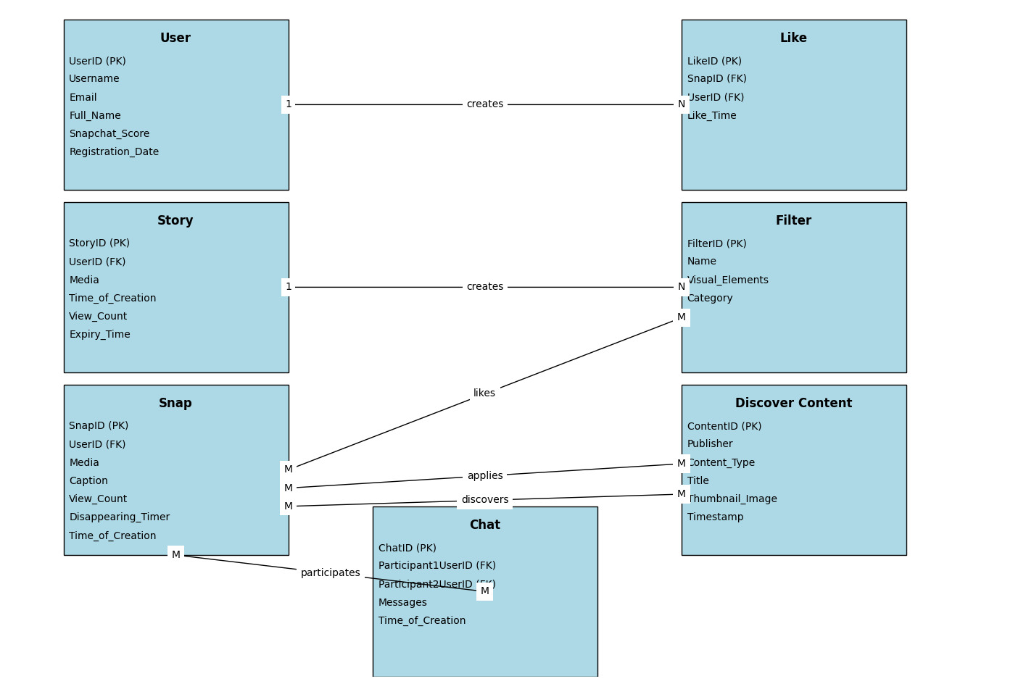

### **Conclusion**

In conclusion, Snapchat's schema and Entity-Relationship diagram offer a comprehensive view of the platform's design, showcasing its innovative approach to digital communication. By addressing real-world challenges such as privacy concerns and content authenticity through features like disappearing messages and augmented reality filters, Snapchat has revolutionized how users connect and share moments. Its emphasis on creativity and spontaneity has made it a standout in the social media landscape, particularly among younger demographics. Overall, Snapchat's schema underpins its seamless functionality and enduring popularity in the digital age.